Skater 911 Flash Movie

Home page image
Need a looping flash image to emphasize “enhanced” -- approximately 40 x 70 pixels (Cori will decide final measurements). It should show the skater guy with a cast, in color—something like the images below.
We would also like the skater to move—pick his skate board up/put it down, move his quirked eyebrow, something similar.
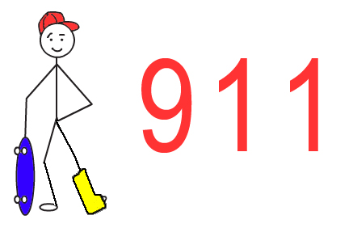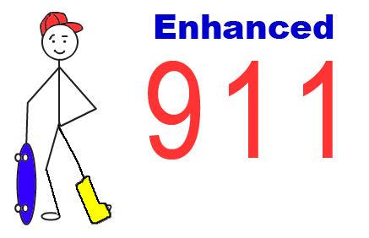

Signal
Change signal from current version to a red dot with four points around it. I love the pulsing thing, just want the signal simpler!

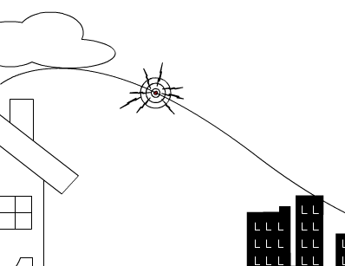
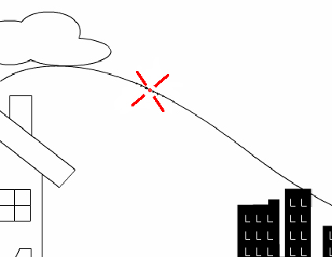

Fire Station
Change Fire Station sign from “F.D.” to “Station #3.”
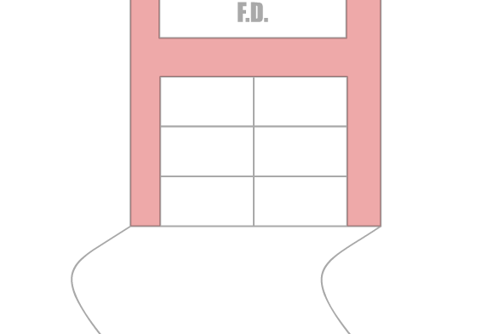

Final image
Add skater guy in cast to final image. Make ambulance a bit smaller, put it in frame and have it leave instead of arrive. (Yes, the guy already being in a cast defies logic, but this may lessen the need for a falling down sequence.)
Add link to more information about E911. Need to rescue this info from the E911 info posted for FCC requirements. Make Enhanced 911 change or underlined? You tell me what’s best.
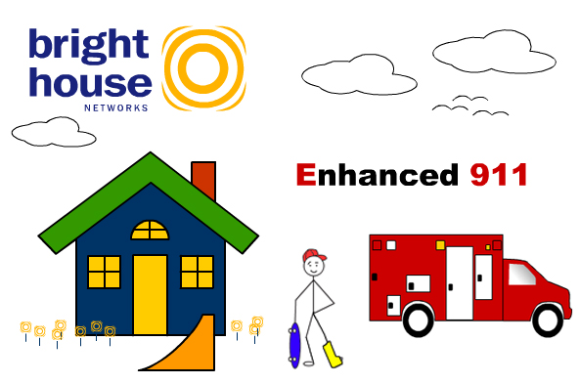

Falling down sequence (Desired)
I would like to see what’s feasible—people would like to see the skater guy fall down, but I don’t know if this will fly.

